# Azure Storages (File, Blob, Queue, and Table) and Use cases

Overview of Azure Storage Solutions

**1️⃣ File Storage**

Azure File Storage offers shared storage for applications using the standard Server Message Block (SMB) protocol. It allows cloud or on-premises deployments to share data easily. Azure Files is ideal when you need shared access to data among multiple virtual machines or when migrating traditional applications that use file shares to the cloud.

**Use Cases:**

* • Lift-and-shift migrations requiring shared file systems.
* • Shared configuration or log data across multiple VMs.
* • Applications requiring file-level access with SMB/NFS support.

**2️⃣ Blob Storage**

Azure Blob Storage is an object storage solution optimized for storing massive amounts of unstructured data such as images, videos, backups, and documents. It supports block, append, and page blobs and integrates seamlessly with Azure Data Lake and analytics services.

**Use Cases:**

* • Storing images, videos, and documents.
* • Backup and disaster recovery.
* • Data lakes for analytics and machine learning pipelines.

**3️⃣ Queue Storage**

Azure Queue Storage is designed for message-based communication between application components. It helps decouple components, ensuring reliable message delivery between cloud services and applications.

**Use Cases:**

* • Asynchronous communication between microservices.
* • Task scheduling or load leveling between app components.
* • Building scalable and resilient distributed systems.

**4️⃣ Table Storage**

Azure Table Storage is a NoSQL key-attribute data store used to store structured, non-relational data. It is highly scalable and provides fast access to large datasets with low latency.

**Use Cases:**

* • Storing user profiles or metadata.
* • IoT data collection where fast writes are needed.
* • Storing structured, non-relational application data.

**Summary & Comparison**

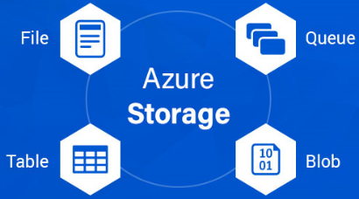

Each Azure storage type serves a unique purpose. File Storage is for shared files, Blob Storage for unstructured large data, Queue Storage for reliable messaging, and Table Storage for scalable structured NoSQL data.

|  |  |  |  |  |
| --- | --- | --- | --- | --- |
| Storage Type | Data Type | Access Method | Best For | Example Use Case |
| File Storage | Files | SMB/NFS | Shared access & lift-shift apps | Application file shares |
| Blob Storage | Unstructured objects | REST API | Large data storage | Media & backup |
| Queue Storage | Messages | REST/SDK | Decoupling services | Task queueing |
| Table Storage | Structured NoSQL | REST API | High-volume data | User profiles, logs |